Harry’s Day
Cut out and paste in the right order
Wrong order | Right order
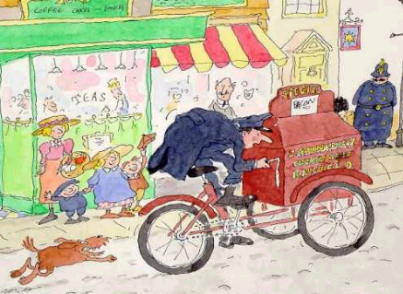 | 1
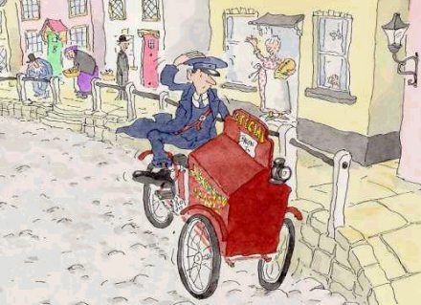 | 2
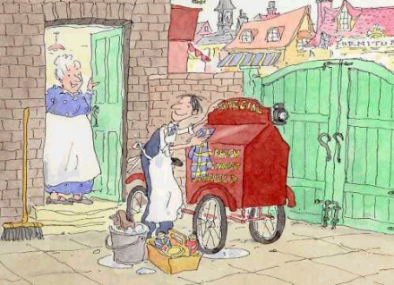 | 3
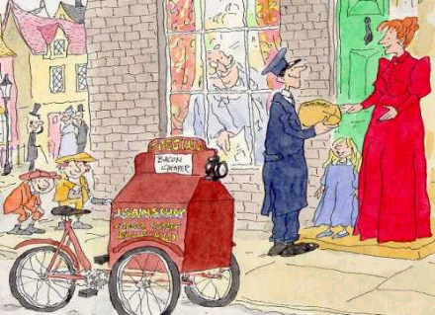 | 4
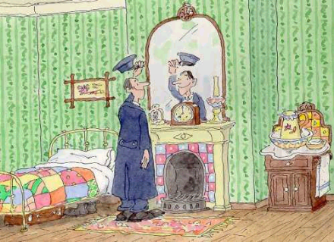 | 5
Harry’s Story

Fill in the missing words

Every day before _______ he would get up and _____ his delivery bike.

After breakfast he would put on his ______. First his big strong _____ and then the coat with shiny ______ and finally the ____.
A hundred years ago very few people had ___. Harry's job was to carry their _____ in his ______.
'This hill is _____’ said Harry, 'I wish I had _______ to help me _____.'
At last Harry has _____ the goods. Then it was back to the _____ for another _______.
Riding a bike was ______ because the streets were made of _____ and the bike had _____ made of solid ______.
After a long day's ____, Harry was ____ and ready for a _____ of bangers and ____ back at the shop.
The Victorian street – then and now

Look at the pages of Harry’s story to see the Victorian street of 100 years ago. Think about what you see in a street today.
What can you see in a Victorian street?
What can you see in a street today?

 | In a Victorian street | In a street today
What the delivery boys ride
The surface of the street
The clothes that people wore
The uniforms of the delivery boys
The fronts of the shops

